Dhaka Metro

Assignment submitted by:
SN | Student Name | Student ID
1 | Tabassum Aktar Sadia | 23-52427-2

Selenium IDE setup in Browser step by step :
1. Go to https://www.selenium.dev/selenium-ide/ and click “Firefox Download“
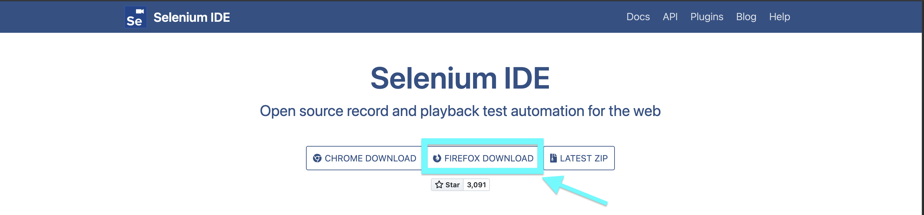
2. The Firefox Download will send us to Firefox Web Store where we can add the selenium IDE extension to our browser and then click “add to Firefox ” button on the right.
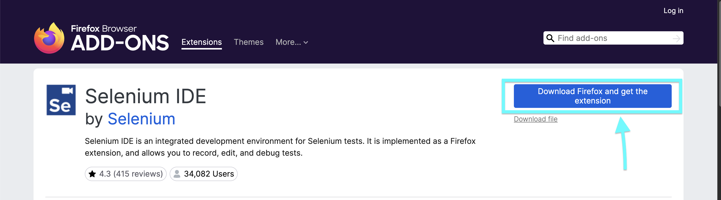

3. Go to browser’s extension and select selenium ide extension
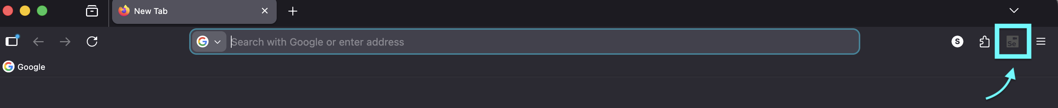

4. Select “Record a new test in a new project” to create and record new project ( Select “Open an existing project” to test existing project that was created previously) then name the new project . After that give the base URL where the test will start recording .
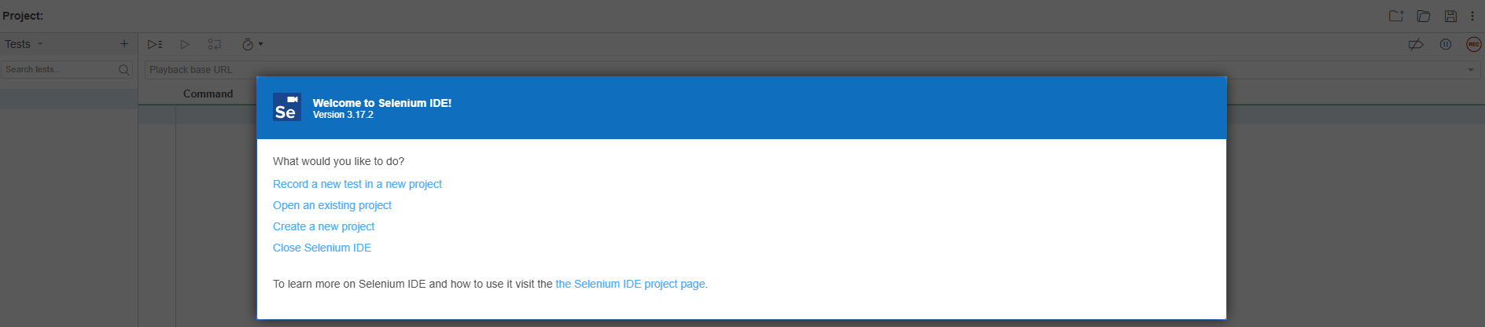
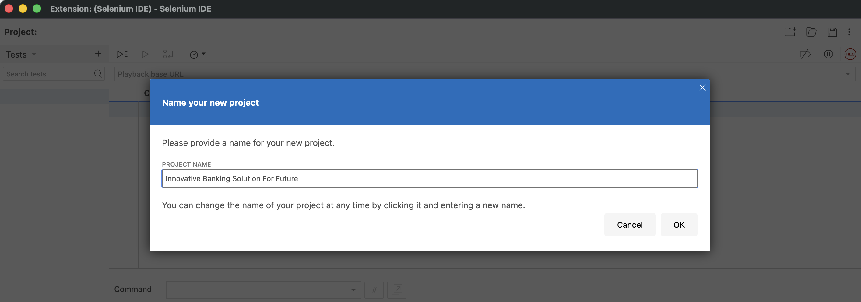
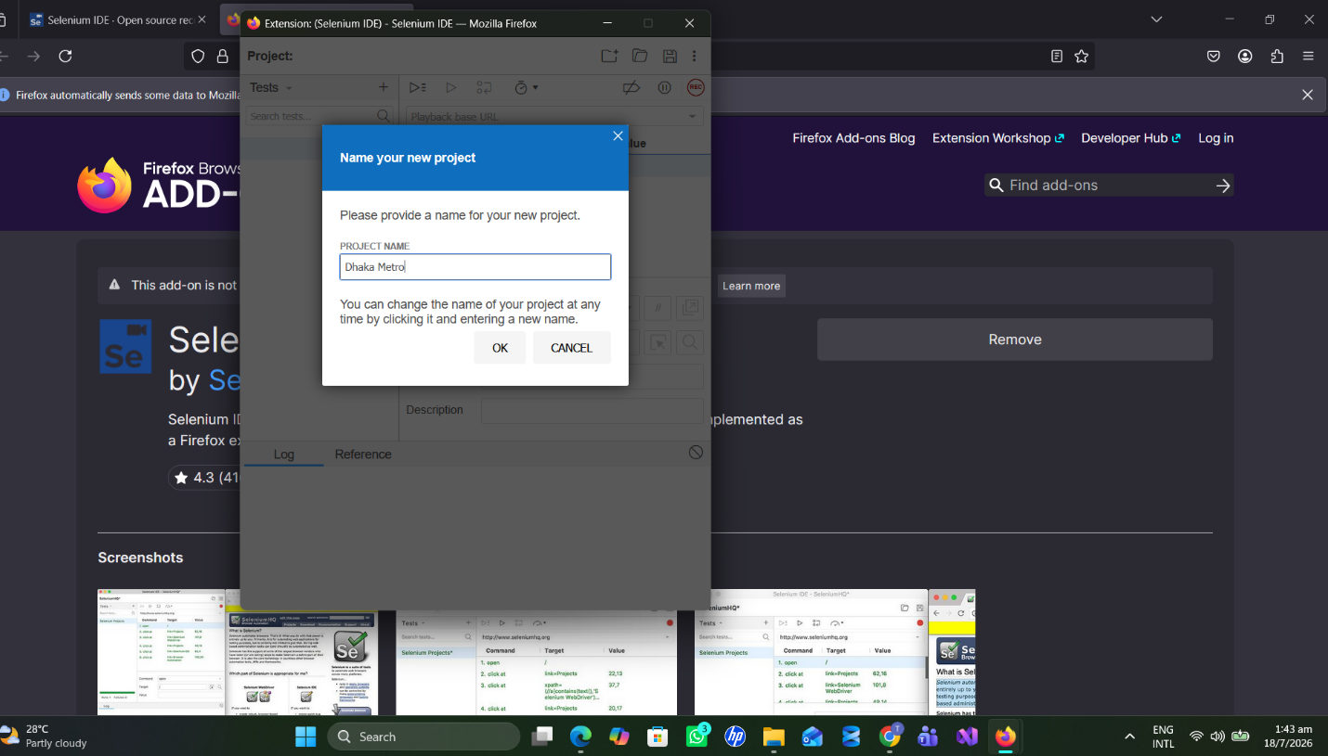

5 Click on the “+” in the “Test” box and name the test to Passenger Login and Logout.
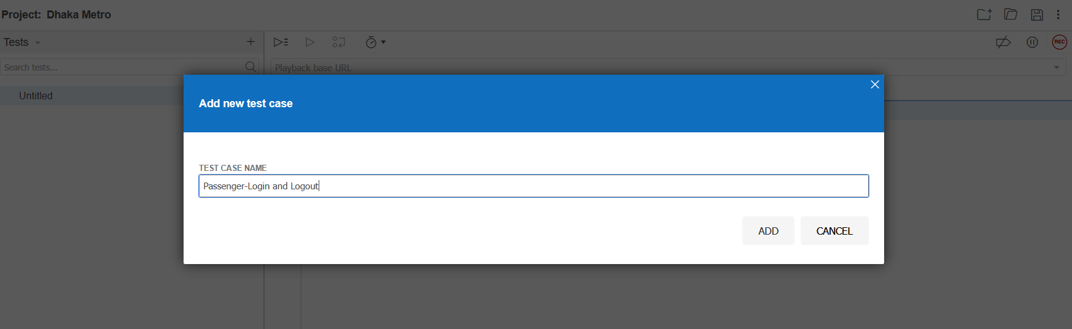
6. Set the base URL and hit “REC” in the top right to start recording the test. Do the test in the browser, after the test is done close the browser and hit the “REC” button again to stop the recording of the test.
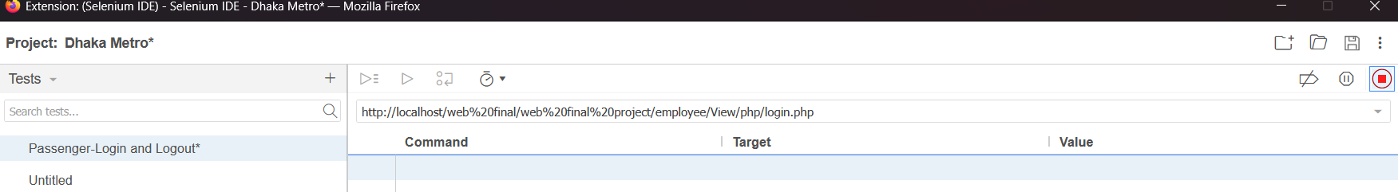

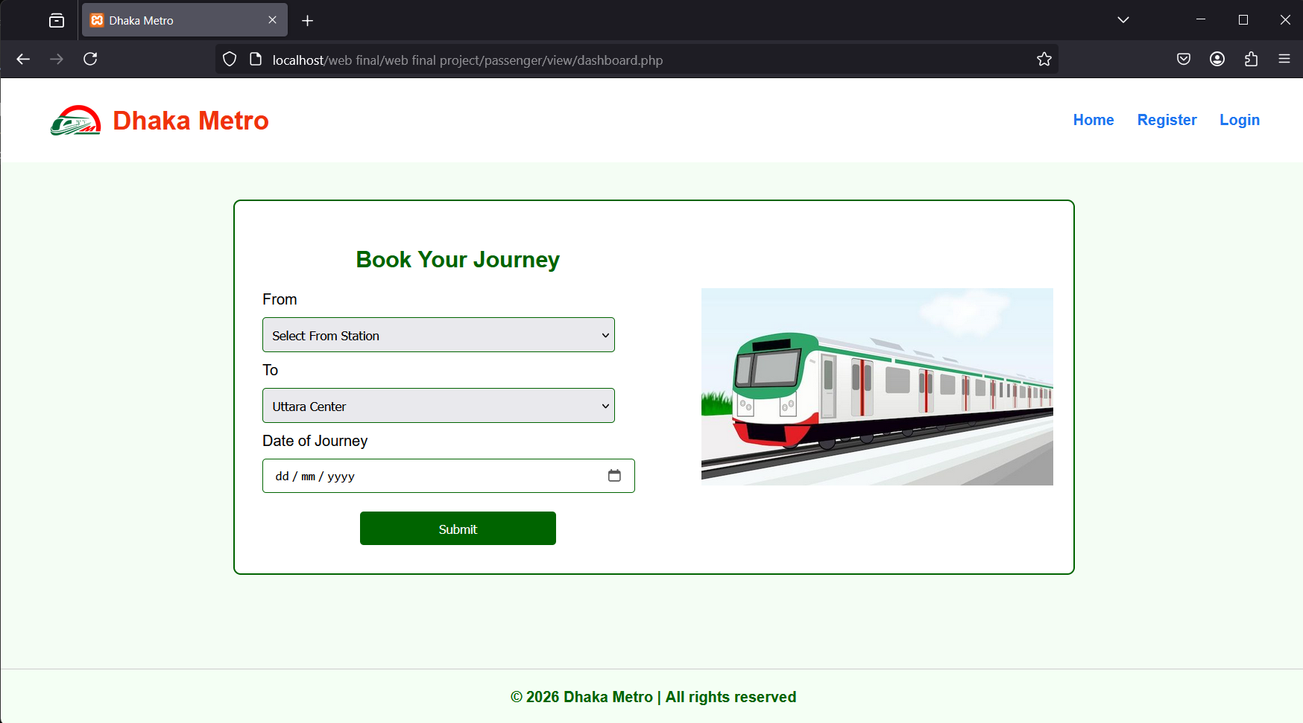

Testing:
7. Passenger Login and logout testing
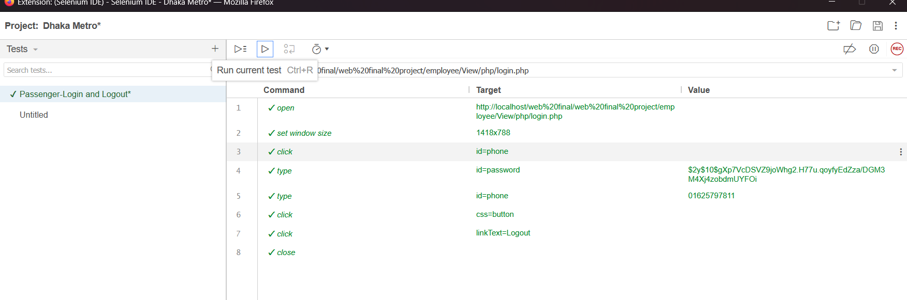

8.Passenger Ticket Buy and payment
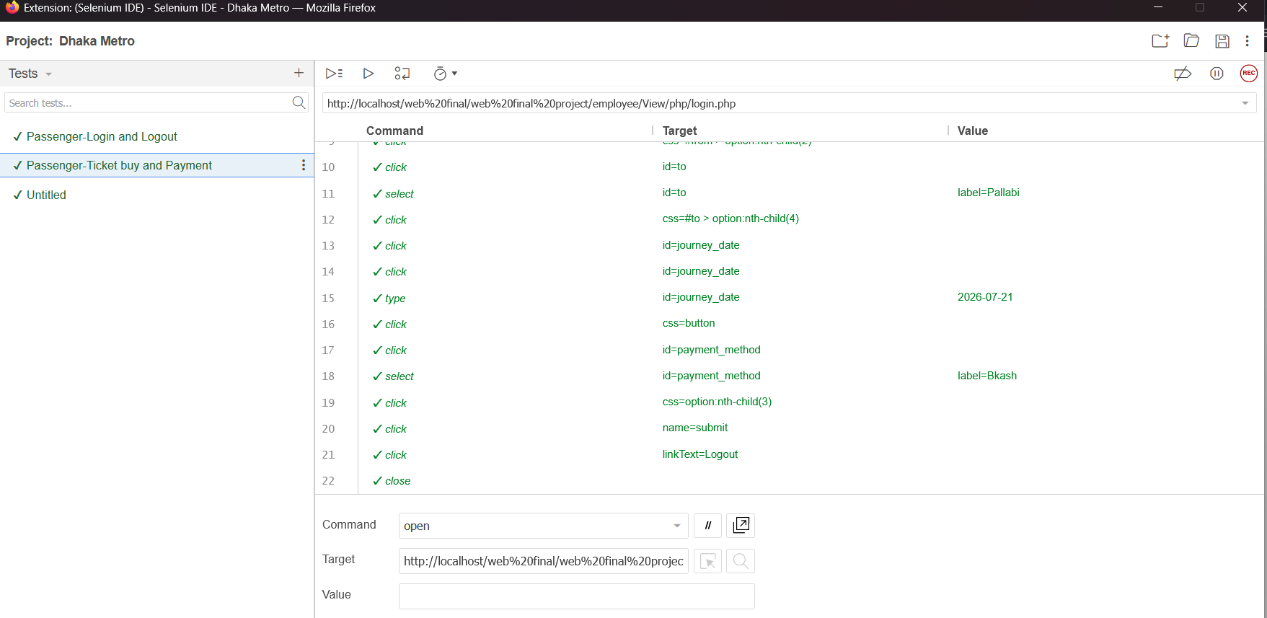

9. Passenger Update profile
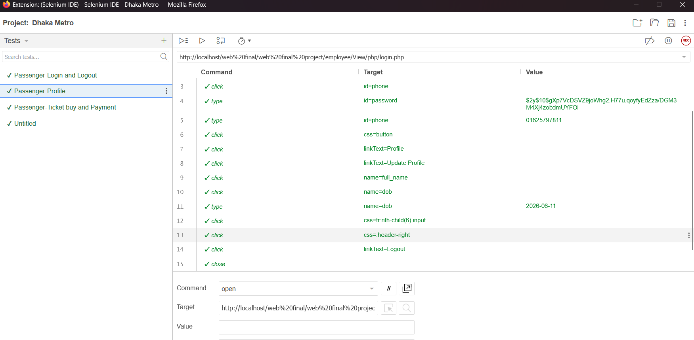

10. Passenger Journey History
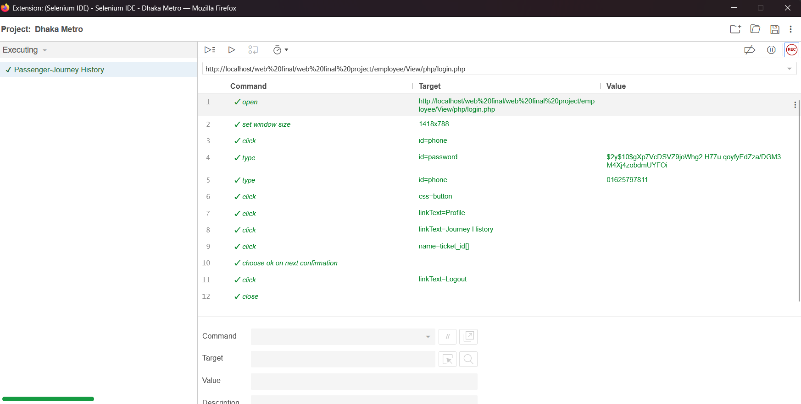
11. Passenger Payment History
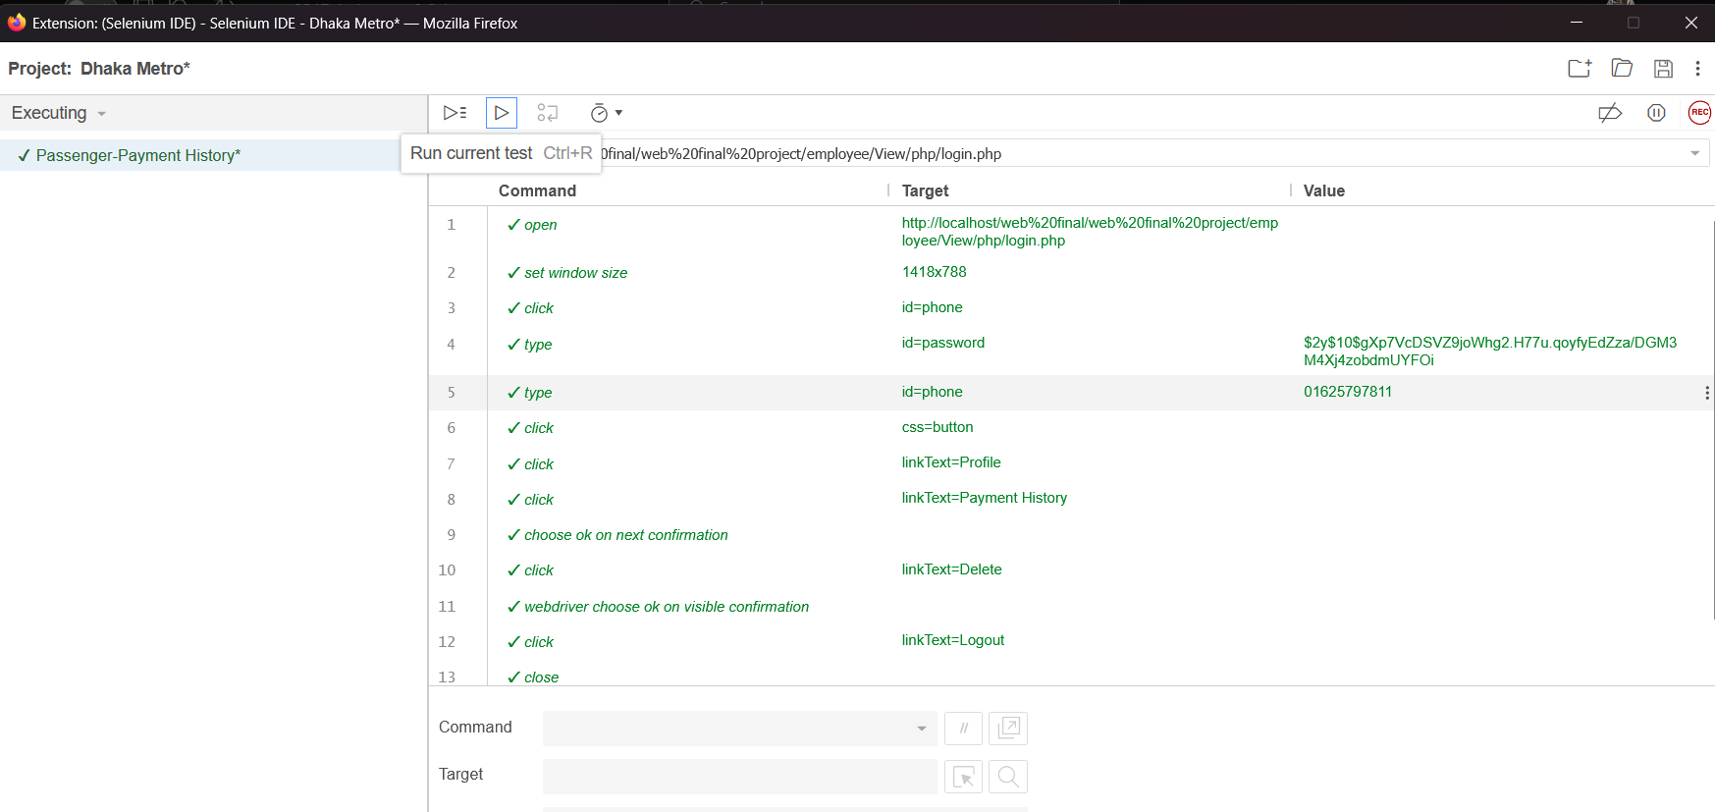

12. Passenger Ticket History
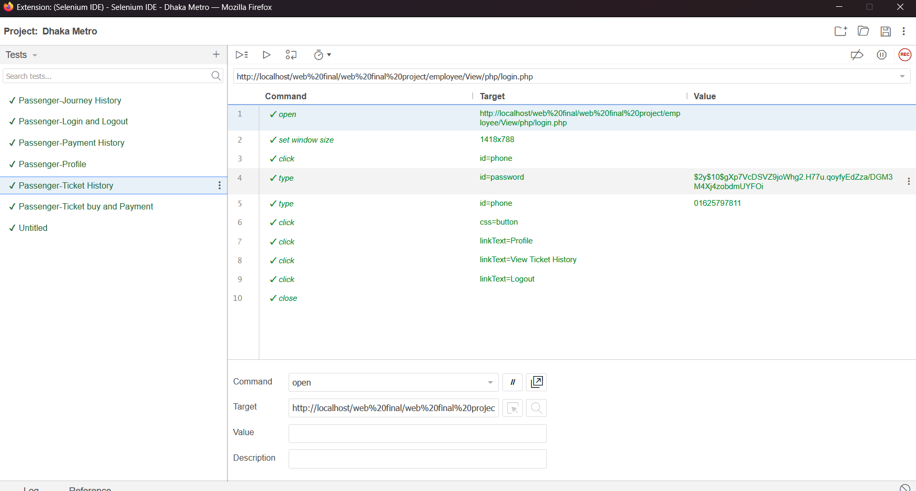

13.Admin Dashboard
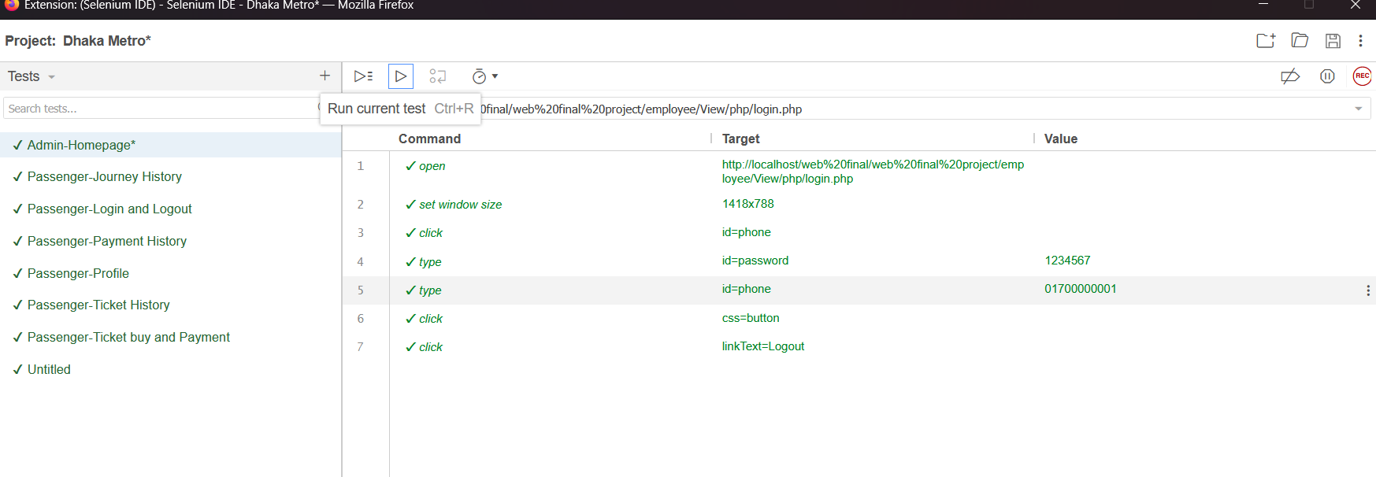

14.Admin Add Route and Staff
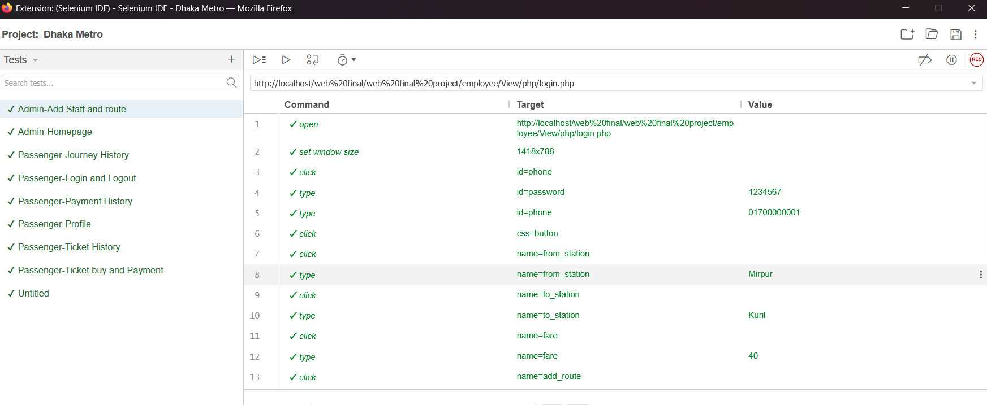

15.Admin delete Route and Staff
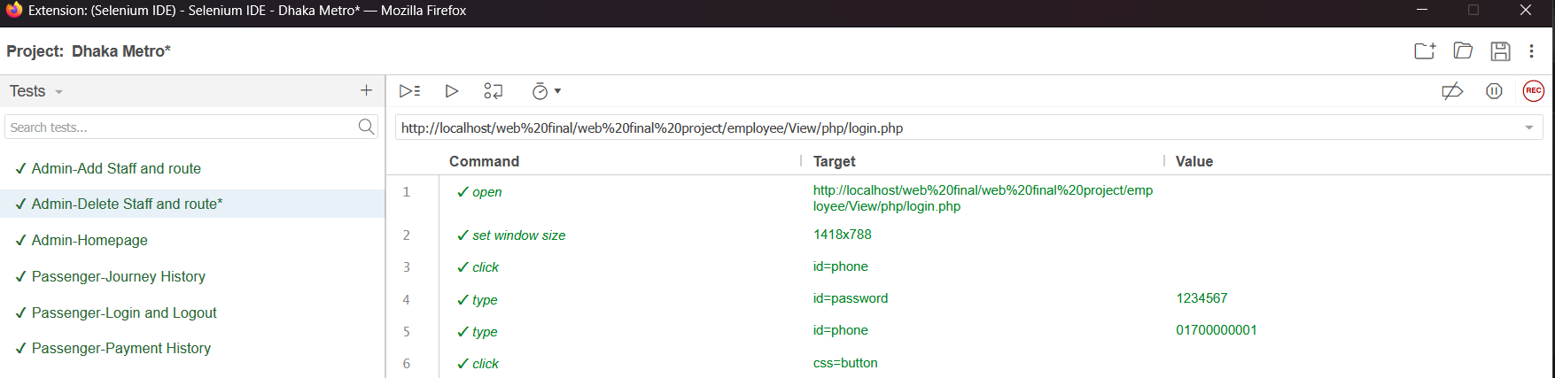

16.Admin Update Profile
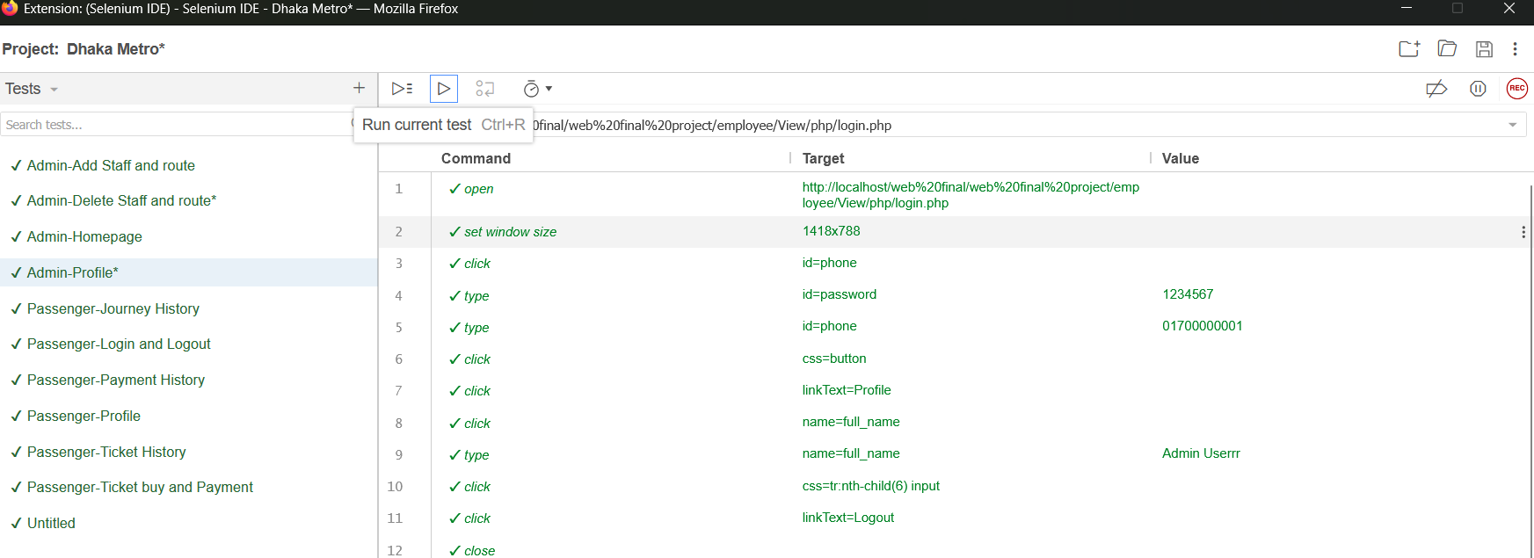
17.Employee Dashboard
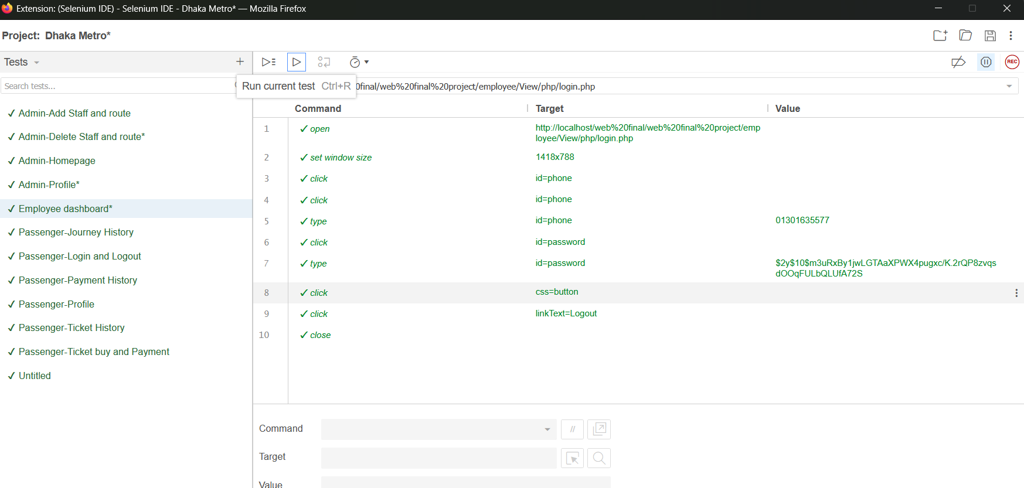

16.Employee Update Profile
